Insert your name, centre number and candidate number into the header above.
Save this evidence document as evidence_ followed by your centre number_ candidate number, for example: evidence_ zz999_9999.doc
Screenshots or program listings must be copied into appropriate cells in the following tables.
Examiners must be able to read the contents, including any screenshots, without the use of a magnifying glass. Answers that are not readable or are missing will not be awarded any marks.
Save this evidence document at regular intervals, for example every 10 minutes.
Question 1
Part 1(a)
global Jobs # global integer, 100 by 2 elements
global NumberOfJobs #global integer
Jobs = []

Part 1(b)
def Initialise():
global Jobs
global NumberOfJobs
for x in range(0,100):
Jobs.append([-1,-1])
NumberOfJobs = 0

Part 1(c)
def AddJob(JobNumber, Priority):
global Jobs
global NumberOfJobs
if NumberOfJobs == 100:
print("Not added")
else:
Jobs[NumberOfJobs] = [JobNumber, Priority]
print("Added")
NumberOfJobs = NumberOfJobs + 1

Part 1(d)
Initialise()
AddJob(12, 10)
AddJob(526, 9)
AddJob(33, 8)
AddJob(12, 9)
AddJob(78, 1)

Part 1(e)
def InsertionSort():
global Jobs
global NumberOfJobs
for I in range(1, NumberOfJobs):
Current1 = Jobs[I][0]
Current2 = Jobs[I][1]
while I > 0 and Jobs[I-1][1] > Current2:
Jobs[I][0] = Jobs[I-1][0]
Jobs[I][1] = Jobs[I-1][1]
I = I-1
Jobs[I][0] = Current1
Jobs[I][1] = Current2

Part 1(f)
def PrintArray():
global Jobs
global NumberOfJobs
for X in range(0,NumberOfJobs):
print(str(Jobs[X][0]), "priority", str(Jobs[X][1]))

Part 1(g)(i)
InsertionSort()
PrintArray()

Part 1(g)(ii)
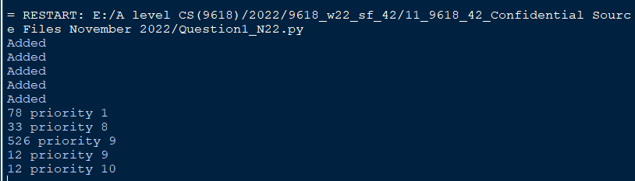

Question 2
Part 2(a)
class Character:
#private Name as string
#private XCoordinate as integer
#private YCoordinate as integer
def __init__(self, Namep, Xcoord, Ycoord):
self.__Name = Namep
self.__XCoordinate = Xcoord
self.__YCoordinate = Ycoord

Part 2(b)
def GetName(self):
return self.__Name
def GetX(self):
return self.__XCoordinate
def GetY(self):
return self.__YCoordinate

Part 2(c)
def ChangePosition(self, XChange, YChange):
self.__XCoordinate = self.__XCoordinate + XChange
self.__YCoordinate = self.__YCoordinate + YChange

Part 2(d)
Characters = []
TextFile = "Characters.txt"
try:
File = open(TextFile , 'r')
for X in range(0,10):
Name = File.readline().strip()
Xcoord = File.readline().strip()
Ycoord = File.readline().strip()
TempC = Character(Name, int(Xcoord), int(Ycoord))
Characters.append(TempC)
File.close()
except:
print("File not found")

Part 2(e)
Position = -1
CharacterName = ""
while (Position == -1):
CharacterInput = input ("Enter the Character to move").rstrip('\n').lower()
for Count in range(0, 10):
Temp = str(Characters[Count].GetName().lower().strip())
if (Temp == CharacterInput):
Position = Count

Part 2(f)
IsValid = False
while (IsValid != True):
Move = input("Enter A for left, W for up, S for down, or D for right")
if (Move.upper() == "A"):
Characters[Position].ChangePosition(-1,0)
IsValid = True
elif (Move.upper() == "W"):
Characters[Position].ChangePosition(0,1)
IsValid = True
elif (Move.upper() == "S"):
Characters[Position].ChangePosition(0,-1)
IsValid = True
elif (Move.upper() == "D"):
Characters[Position].ChangePosition(1,0)
IsValid = True

Part 2(g)(i)
CharacterName = Characters[Position].GetName()
print(CharacterName, " has changed coordinates to X = ", str(Characters[Position].GetX())," Y = ", str(Characters[Position].GetY()))

Part 2(g)(ii)
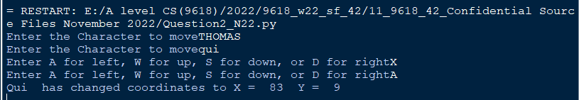

Question 3
Part 3(a)
global Queue
global HeadPointer
global TailPointer
Queue = [ -1 for I in range(100)] #Integer
HeadPointer = -1
TailPointer = 0

Part 3(b)
def Enqueue(Data):
global Queue
global HeadPointer
global TailPointer
if (TailPointer < 100):
if HeadPointer == -1:
HeadPointer = 0
Queue[TailPointer] = Data
TailPointer = TailPointer + 1
return True
return False

Part 3(c)
Success = True
for Count in range(1,21):
Temp = Enqueue(Count)
if Temp == False:
Success = False
if (Success == False):
print("Unsuccessful")
else:
print("Successful")

Part 3(d)
def RecursiveOutput(Start):
if (Start == 0):
return Queue[Start]
else:
return Queue[Start] + RecursiveOutput(Start-1)

Part 3(e)(i)
print(str(RecursiveOutput(TailPointer-1)))

Part 3(e)(ii)

